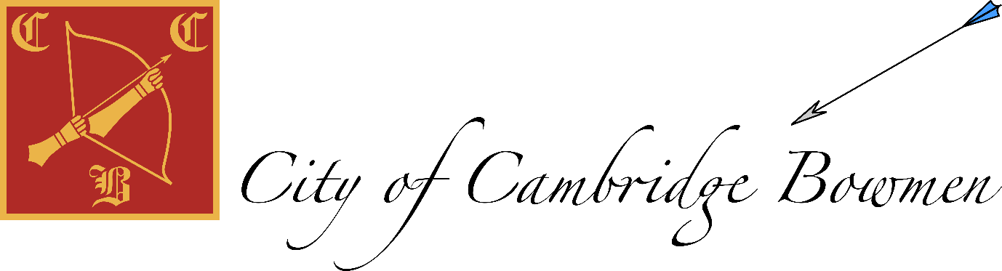
Committee meeting 14 August 2021
Zoom
Present: Carl (treasurer), Jack(Chair, equipment), Seb (Records, Lydia (captain), Patrick (Secretary), Anke (Tournaments), Richard (ordinary member)
 | Item | Aim
1 | Officer Reports |  | Actions
 | AGM minutes | All happy | Jack remind Nick about audit  Jack
Secretary | Feedback from members on Chair swap  Documents update | 3 comments from membership- 2 very positive, one suggesting EGM  ………………………………  Information  Encourage new members (all)  Leave reduced cttee few for now  Information  Mailing list purge,  Make it private | Patrick to confirm to membership
 | Membership (see report) | Need more members, all to encourage retention.  Leave reduced membership fee for now
 | AGB renewal, fee structure | Due September
 | Treasurer  Budget 21-22 | Information  £16k balance  Will need a new treasurer at AGM  Club likely to be in deficit again in 2021-22, | Jack invoice CUB ‘rent’  When inventory of shed carried out evaluate if £4.5K disaster recovery fund is adequate- Jack
 | Tournament  State and plans for 2022 Competition, Postal League results | Information  Refund requested (WRS fee)  Tournament plans  Plan to go ahead with double 720 format but with medals for winners  Discuss helpers with membership but manage with what we have , potentially reduce kitchen offering.  Brian lined up to judge  Paperwork in in autumn  Book weekend with Downing  Research medals (Lydia)  Jack to lead on IANSEO  Risk assessment needed near the date.  Early advertising esp. in County  Fee was £18 for the day, archer pays EB fee (?)  14/15 may  Postal league results incomplete | Anke chase WRS fee refund  Anke book weekend of 14/15 may with Downing  Lydia source medals for tournament  Investigate IAnseo for scoring -Jack  Anke/ committee, finalise fee nearer date and decide who pays (CCB or archer)  Anke post postal league results when complete  Discuss interest in helping with membership. (8 per day)
 | Equipment  Ordering bows for beginners course,  Budget  shed code | Budget decision  £300 spent on kit for courses  Nominal £100 more for rest of year,  Most kit OK fo now  Beginners course bows tbd  Shed code change now at end of membership year | Jack- shed code in September?
 | Records  Current state of badges/awards and moving forward  Handicaps and classifications, updating records online | Information  £2 patch  £2 badge  £lanyard 2  Publicise 720 award  Keep WA arrow and 252 award (Jack to tell DL if he wants to run this)  Lists  Portsmouth and frostbite review use over winter. 2 scores  Emphasise classifications more  Jack to mail members  https://cubowmen.com/awards_internal#wa-arrow-badges  https://shop.worldarchery.org/collections/beginner-awards/products/beginner-arrow-awards | Seb  Advertise badges for sale  Remind members to submit scores at start of indoor season  Order more WA white? And other colours  Jack, message about awards to David.
 | Captain  Club end of season shoot  Jelly bow clout with new members | Information/ discussion  Agree plans  Plan fun shoot  Huw? 12 sept??  Making sure someone is there at start time for sessions?  Weekday sessions, new members need help from ?? O’clock  Use WhatsApp for informing people If shooting/ planning to shoot by lunch time. Encourage new members to join WhatsApp | Lydia- discuss fun shoot with Huw  Patrick- tell new guys about WhatsApp and add as appropriate
 | Website –  Updates  account access  Google calendar  Records | Discussion, agree actions  Records to web site  Scrap google calendar | Jack, records to web site
 | Chair  Plans going forward  feedback from CAA meeting  club keys | Discuss and agree  Need o break even.  Recruitment and retention. Sense of community, shoot together. (2022)  Information  Agree best key holders  Jack to acquire keys from Carl  Check 3rd set of indoor keys  DL, HH, TB | Jack  Get keys from Carl  Jack check indoor keys and get set if possible
2 | AGM minutes | Outstanding actions | Jack
3 | Town vs Gown | Decision/ plan  J26/9 not possible Jack, Lydia absent, Patrick absent.  Do we have organisers/ shooters (4 recurve)  Try 3/10? PASS to discuss with downing and every Saturday | Jack- contact CUB re 3/10  Patrick discuss 3/10 with Downing  Discuss Saturday use with downing
4 | Indoor shooting - Approach and booking | Discuss agree  AGB guidance is that we’re free and clear.  6 bosses,  ? Maybe 4-5 bosses, masks.  Ventilate.  Booking  4 Oct, booking scheme. | Patrick book with Coleridge
5 | Running a beginners’ course Sept 2021  See attachment | Agree plan  However many D and J can manage @ downing | Jack contact David
6 | Request by David Long for club to book and fund winter coaching  See attachment | Discuss proposal  No enough members to fill all those sessions  Fund every 2 months- meets club needs  Oct dec feb, more if needed. | Jack contact David
7 | Date of next meeting | Agree 2 months  Doodle, October week of 11 Oct Winter shooting | All
8 | AOB |  | All

Attachments
- Membership report
- Beginners’ discussion
- Coaching discussion
- 2021 AGM minutes

