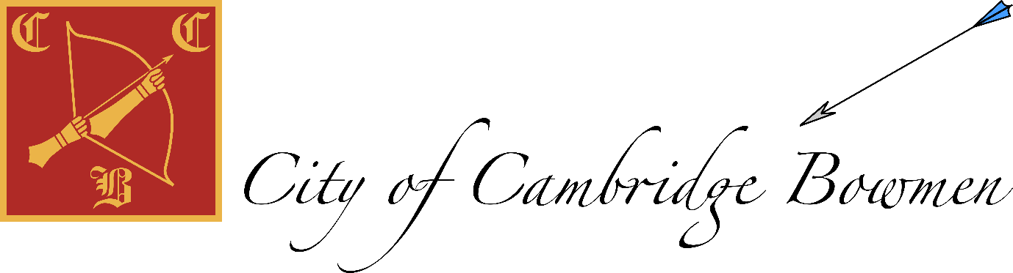
Committee meeting 12 December 2021
15.00
Downing Pavilion
 | Item | Aim
 | Apologies  Seb A  Present  Jack (chair)  Anke (tournaments)  Patrick (secretary)  Lydia (Captain)  Nick (Treasurer)  Richard (member) |  | Patrick
 | Minutes of October meeting  approved |  | Patrick
 | Matter arising and review of actions |  | All
1 | Officer Reports
 | Chair  Club seems to be doing OK  Some of the new starers from beginners courses appear keen and are attending regularly  Club fees have not changed for 10 years, while there is no need to increase fees in the short term should cots increase we would ned to reconsider (eg if indoor capacity became an issue and we had to find a larger facility |  | Jack
 | Secretary  Membership report  3 experienced joiners, including one junior  No information on November beginners, see below | Information  Information/action | Patrick
 | Treasurer  Nick has what is needed to complete the handover  Need to change official address and add 3rd signatory (secretary) | Jack, still to get Downing keys from Carl? | Nick
 | Tournament  Access granted to sport80  WRS approved  Eventbrite can Go liv eASAP  Advertise where we can  Members can be prioritized  Medals still on Lydia’s list | Mention help to members  Jack/Anke  Jack/anke to email JG at CAA  Anke, open booking on eventbrite | Anke
 | Equipment  Faces bought | Winter storage  Review when course is complete
 | Records  CCB Golden Records Online account  Look at in 2022 (Jack and Patrick) | Information | Seb/jack
 | Captain  Christmas shoot go ahead  Town vs Gown report pending |  | Lydia
 | Website –  New pages.  ‘for sale’ page | Patrick, set up google sheet for sale items with ‘form’ for data entry | Jack
 | Safeguarding | We have juniors, but hopefully nothing to report! | Anke/Jack
 | Coaching  Nov course, last week postponed due to power failure, deferred to 28 January  March would be preferred time for another course. | Information | Patrick/Jack
3 | Review winter/spring coaching  Feb scheduled, run more next year  Beginners taking this up  Tidy up awards  Arrows aeardsneed to be publicized | Jack- discuss with David plans for 2022 coaching sessions  Outdoor Sundays?
7 | Doodle for date (Patrick | Did we pick a date? | All
8 | AOB |  | All

