City of Cambridge Bowmen

The 70th Annual General Meeting of the City of Cambridge Bowmen will be held on Zoom
On Saturday 24th April 2021, commencing at 2:00pm

Agenda

- Apologies for absence
Adam Edwards

Present:
Committee: Patrick Sinnett-Smith, Carl Bunting, Anke Hannemann, Seb Allouis, Huw Howell, Lydia Sinnett-Smith, Jack Atkinson
Members: Nick Tiley, David Long, Jamie Pirie

- Minutes of the 2020 Annual General Meeting
Approved (and attached)

- Matters Arising
None
- Chairperson Report
Hi all,

Like many of you, I’m personally fed up of hearing about how this has been an “unprecedented year”, the extent that it has disrupted our lives, the increased amount of energy required to get anything done and above all… the amount of time I spend in front of a webcam and microphone.
This “new normal” is horrid in so many ways but hopefully we’re nearing the end of this and as everyone gets their vaccinations, life will recover to the old normal.

Despite everything thrown at us, the club did manage to keep shooting for a decent chunk of the summer. This wouldn’t have been possible for efforts, time and sheer force of will by some of the club members. I’d like to call out the exceptional efforts of two members.

Lydia started the summer bashing her head against the wall that is Downing college. Patient yet persistent, she repeatedly tried to get a clear direction on whether we’d be able to shoot. As you know, the eventual answer wasn’t what we hoped for and so Lydia then made contact with Philip Watson at Peacocks and arranged a range sharing deal that many of the membership benefited from… and hopefully made some new friends.

Whilst we were grateful to have use of this new venue, spaces in each session were limited and so Jack Atkinson was working hard to secure another venue at Girton.
Handling the relationship with the Girton office, working with them on a quote, providing the risk assessments and eventually closing the deal was no small feat. It is a lovely field and was our fallback option if Downing had not re-opened to us this summer.

Of course, I have seen extraordinary efforts from elsewhere in the club and I’m so thankful to everyone involved.
- Cancelling and refunding our WA720 tournament.
- Volunteers moving equipment to/from Girton
- Trying to keep Coleridge open to shooting throughout the winter
- Reading and trying to decipher the sometimes woolly advice from AGB

We’re still here.. Membership numbers have understandably taken a bit of a hit due to lack of intake we’d normally have however we’re still in a fortunate place financially and I believe that we’ve borne the worst of this.

- Tournament Organiser Report
Tournament Officer – Report 2020/21 – Anke Hannemann

CCB 2020 Tournament – 10th Anniversary

WRS Double WA720 tournament cancelled due to Covid 19. Entries refunded. Application with AGB moved forward to 2021.

Spent £50 on application but this moved on to 2021. We did not spend anything else on tournament preparation (i.e. no new bosses bought etc) but also did not make any money.

CCB 2021 Tournament – 10th Anniversary, the 2nd

Cancelled due to Covid 19 restrictions. Applied for AGB application fee refund (£50).

- Treasurer Report

- Used to run via spreadsheets
- Unwieldy – Carl has moved the accounts to GnuCash (2018 onwards)
- Report to 13th March – didn’t take much in in terms of membership fees, obviously not competition income
- Money out around double money in for the year – made a loss this year which is unsurprising! Compared to two previous years – made small loss in 2019/20, and a gain in 2018/19
- Holding a lot of money in the account, trying to spend money! So mission accomplished, largely through venue hire and smaller income than normal
- Hopefully GnuCash will simplify accounts in future – Carl happy to demo if anyone is interested in Treasurer role
- Auditing – tried to work with Fran but accounts layout and template weren’t very compatible
- Nick volunteered to audit accounts – Carl to arrange this – thank you Nick!
- 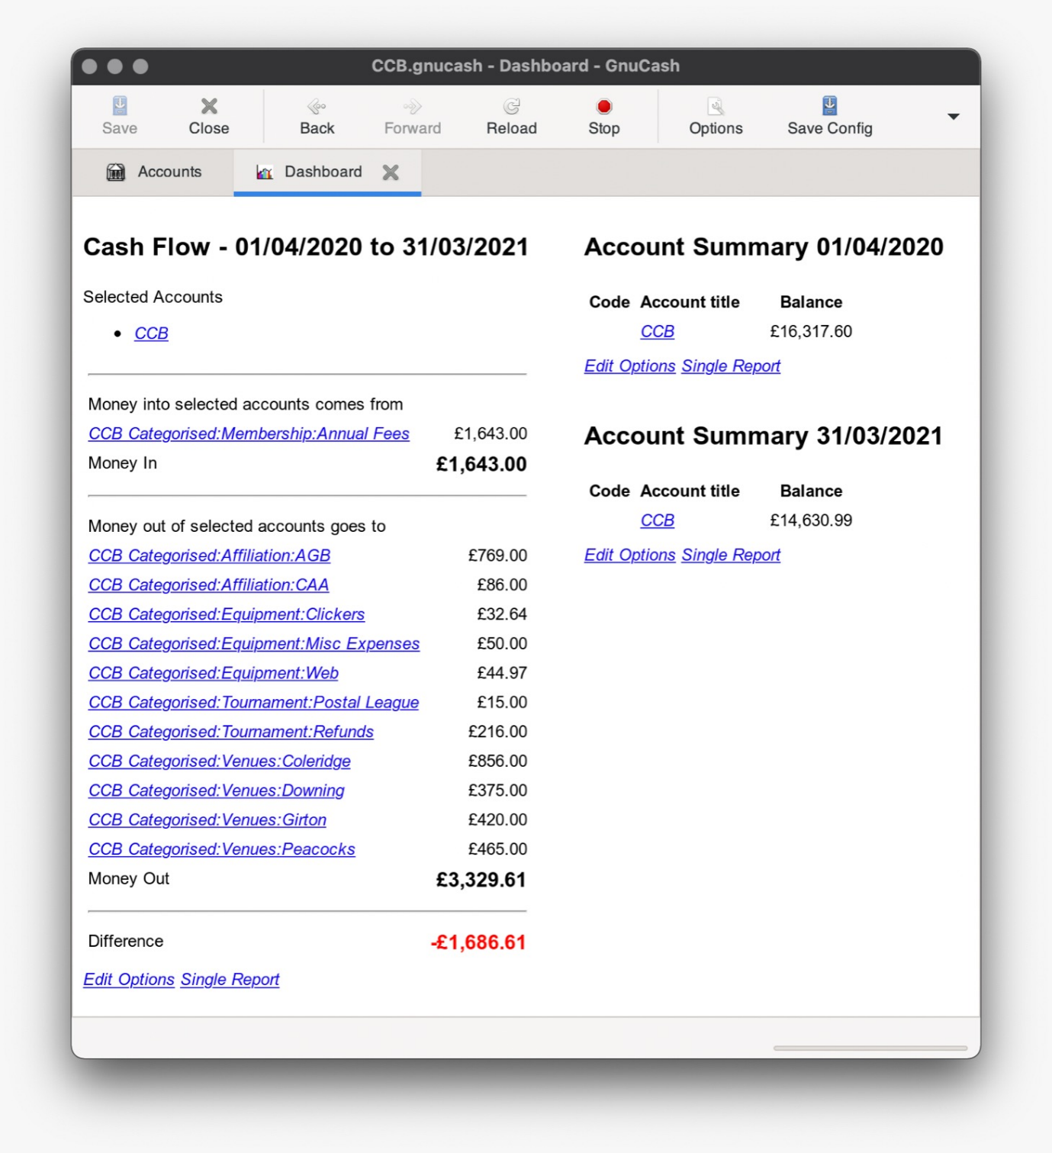

- Field Captain Report (and Soc sec)

Another year without any incidents at any of the ranges, we'll ignore that as a club we've hardly shot over the last year but a win's a win. The same old issues persist with residents and members of the public at Downing but now the university are shooting with us and the college has put up its own signs we stand a fighting chance.

As a committee we were able to adapt to the changing covid regulations and continue shooting when AGB allowed us to do so. This includes implementation of a booking system and dishing out target faces and pins to members as well as enforcing social distancing and face coverings.

During the radio silence from Downing members of the committee were able to negotiate shooting at Girton college while we tried to re-establish communications with Downing, which we now have.

We are currently host the university bow club at Downing. I think this is a brilliant way to help build further ties with them but also having them set up at the left of the field will help us with issue of interlopers from the properties that back onto the field.

I have had considerably more interest from lapsed and established archers wanting to join the club as well as complete beginners. I think the lockdowns have helped us in that sense and I will do everything I can to get them signed up as members.

- Equipment Officer Report

Equipment Officer’s report
24/4/2021

Overview
With the COVID-19 pandemic the role of equipment was somewhat changed this year.

Unsurprisingly there has been very little in the way of ‘normal’ duties due to the lack of club members shooting for much of the year, no beginners’ courses, and hence few new members requesting bowloans.

Loan Bows
There was one bowloan returned during my tenure, and one issued that is still out.

I updated the bowloan form to provide significantly more information about the equipment and state it was in to allow more effective tracking in the future. Previously there have been significant issues with loss and damage of equipment due to not tracking loans in an sufficiently detailed manner. This new document was sent to the secretary to be updated in the documents repository.

Loan bows that I received have been sorted into distinct packages and catalogued (this needs to be sent to the secretary or uploaded as a google doc) ready for future loaning. The club arrows have been grouped into sets with elastic bands and any single of damaged ones set aside or discarded. The club accessories box has been organised and pruned – there were a plethora of damaged components and old packaging that needed removing. I plan to return these to storage at Downing when I get the opportunity.

Purchases
With the aforementioned lack of shooting there was little that required purchasing for the club this year.
With the AGB COVID-19 rules I oversaw the purchase and distribution of a number of target faces and target pins to be issued to members to keep between sessions.

Fields and Moving Equipment
One item of equipment that I did not expect to deal with when taking on this role was a field. Following the closure of Downing due to COVID-19 I led an effort to secure an alternative shooting space at Girton College for summer 2020. Some equipment was moved temporarily for this purpose and has since been returned.

Cambridge University Bowmen (CUB) have joined CCB for the summer of 2021 whilst their venue at Churchill College remains closed. They have moved some equipment over to Downing but I am yet to receive an inventory from them. This will be required to ensure that we each get our own equipment back at the end of this arrangement.

Future Plans
Once things open up more I would like to sort the shed at Downing. This is with a plan to catalogue all of the club’s equipment, and inspect for any items that need repairing, replacing, or upgrading. This will require the assistance of a few other club members however.

I would like to propose the purchase of an essential toolkit for storage at Downing. It has recently come to my attention that a number of items such as screwdrivers, pliers, allen keys, and perhaps a whittling knife would be useful for members to be able to access at the range.

- Records Officer Report

City of Cambridge Bowmen – Record Officer's Report 20.04.2021

This year again has been under the Covid worldwide pandemic, with very limited shooting. As a result, I have not had many people sending me scores (in fact I got only two new records….)

1. Postal Leagues

Due to the pandemic, we did not do the usual postal league in the summer or the winter this year.
There was a CAA summer competition organised by none other than Jack Atkinson. CCB did well and came 2nd (Jack with an average of 667) and third (Lydia with an average of 660) in the compound category and 4th with Anke (with an average of 501) in the recurved category. Well done all!
All going well we will submit a team for the summer league

2. Competitions

Again, the constraints of being in a pandemic meant that we did not do competitions (At least I am not aware of any).

3. New Club Records

According to the scores I have received we have two new club records from Jack.
An updated record list will be shared shortly and I encourage everyone to shoot for some records. There are outdoor rounds that have none and it doesn't matter if it's an age appropriate round. A record is a record!

Outdoor Records:

WA 70m | Jack Atkinson | C Men | 663
WA 50m | Jack Atkinson | C Men | 657

4. Classifications

Regarding the classifications, as we have not really been shooting, we do not have any qualifications.

5. WA70m City of Cambridge Bowmen Badges

6 dozen at 70m for max score of 720. Badges are awarded for reaching each score once and starting at a score of 325.

New achievements at CCB:

Jack Atkinson (C) 650

Some badges still waiting to be distributed to their owners from last year – get in touch if you are owe something! Lydia and Seb to compile list of available badges for the website

- Election of Officers
Chair – Carl (7 for, 1 RON)
Treasurer – Carl (7 for, 1 RON)
Secretary – Patrick (8 for, 0 RON)
Captain – Lydia (8 for, 0 RON)
En-bloc – (8 for, 0 reject)

- Membership Fees for 2021-22 Season
Maintain at existing fees. Approved unanimously

- Any Other Business
  - Creation of club coach role:
Monitors the coaching mailbox and directs applicants to the next beginners course.
Organises and oversees beginners courses and is responsible for the quality of the delivered course.
Covers any requests for membership coaching
Keeps the club updated with coaching matters coming out of AGB

Should be a qualified coach at L1 or better standard

- Discussion – Level 1 coach
- Are we running courses? COVID makes it tricky but can be run currently. Would hope to run a course in the summer all things being equal
- AGB – moving to reintroduce CPD for L1 coaches
- Do have interest in courses and good way to bring in new members
- David – happy to run one-on-one coaching for anyone that has equipment available
- Issue with role – currently have few members and volunteers for the committee in general, and very few L1 coaches. Would it make sense to create a role to be empty?
- May encourage people to become coaches/requalify if lapsed
- Approved, vote tally for: 6, against: 3
- No one standing for role
- No volunteers for L1 qualification – role to remain empty – anyone interested, please contact committee!

  - New logos to be approved
Approved unanimously

  - Huw in discussion with Adam over organising a club fun shoot when this is Covid-allowable – ideas include beginner bow clout, speed shooting, moving target
  - Jack would like access to the website – Lydia to send
  - CUB joining us – helping our cash flow, helping them shoot – hopefully run Town v Gown in some form!
Meeting closed at 3:12pm

